package.Json : Its contains dependencies and scripts required for the project.

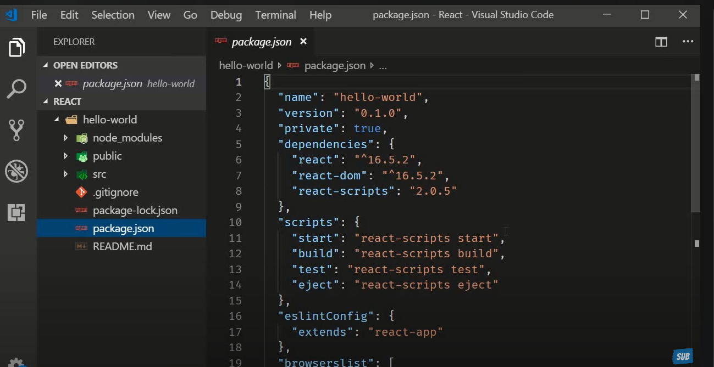

Package-lock.Json : Ensure consistant installation of your dependencies and

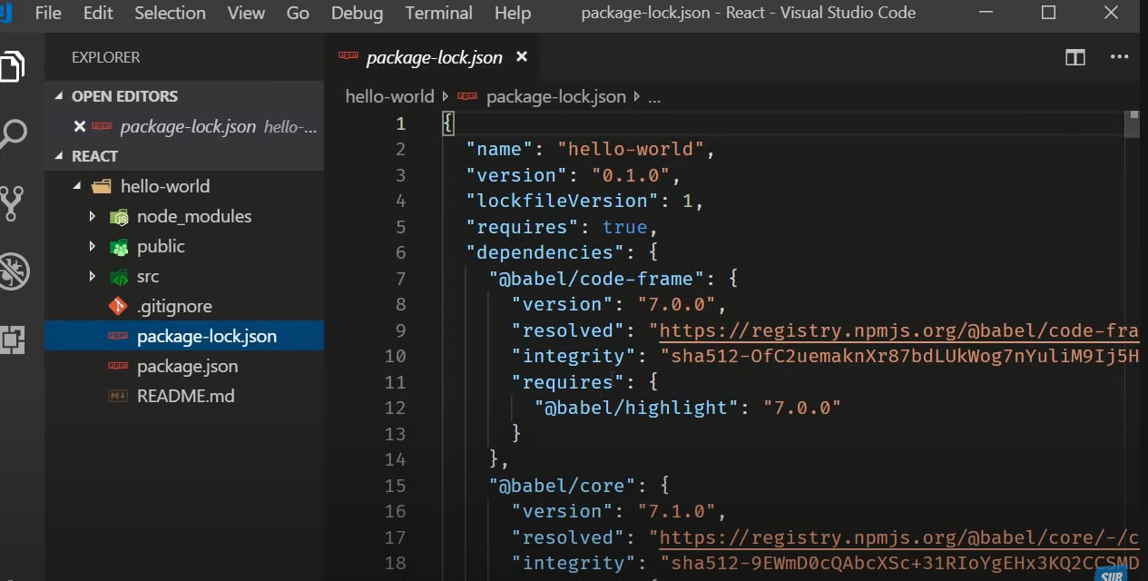

node_modules Folder : All the dependencies are installed it. It is generated when you run the create react app command or when you run npm install.

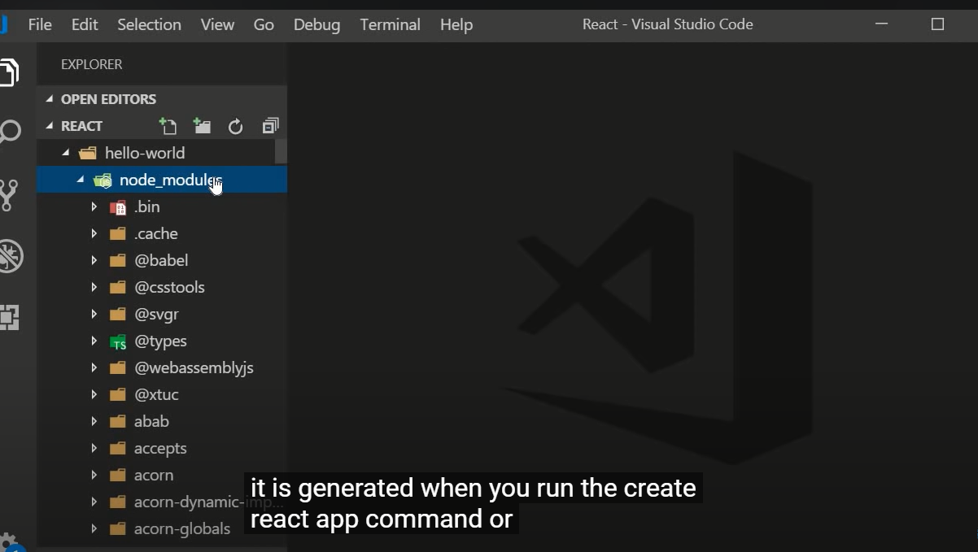

Public folder :

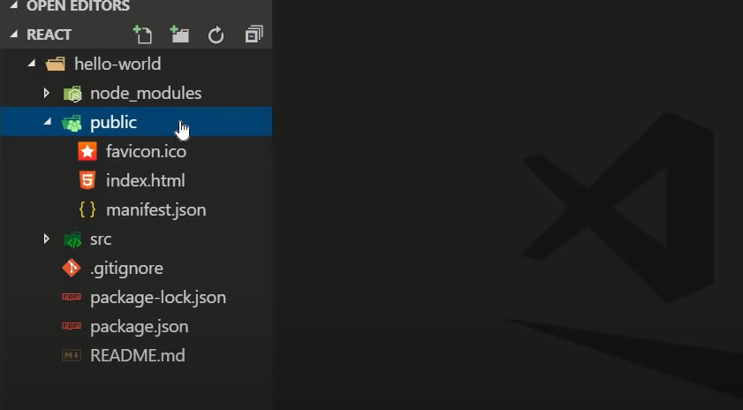

This folder contains three file.

1. Favicon.ico
2. Index.html –

* index.html only this html file we are going to have in our application.
* we are building single applications and this is said the view might dynamically change in the browser but it is this html file that gets served up.
* We are not going to any change in body tag in this file.
* Our react application take over with this div ultimate responsible for the ui.

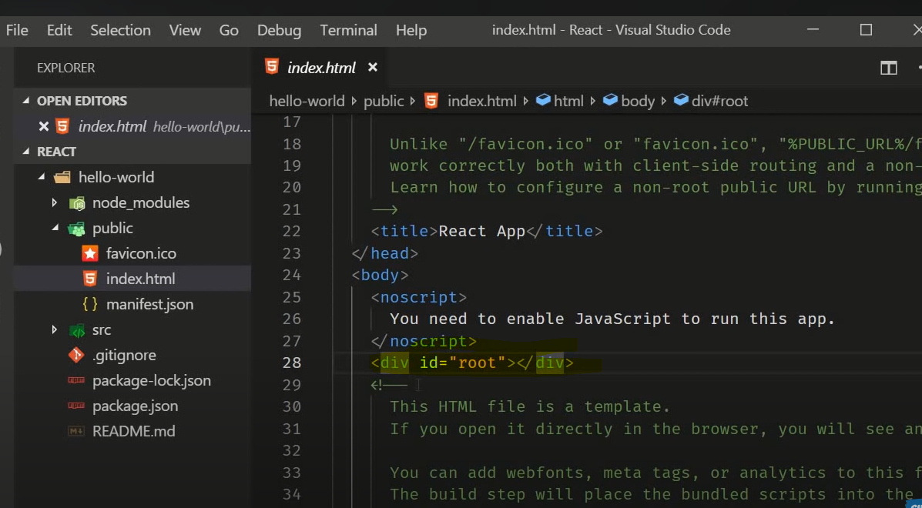

1. Manifest,json : this file is concered with progressive web apps.(out of scope).

Src Folder :

Index.js :

* starting point of the our application is index.js.
* In index.js we specify the root component which is app component and the DOM element which will be controlled by react. Dom element in our example is an element with an id of root (Index.html)

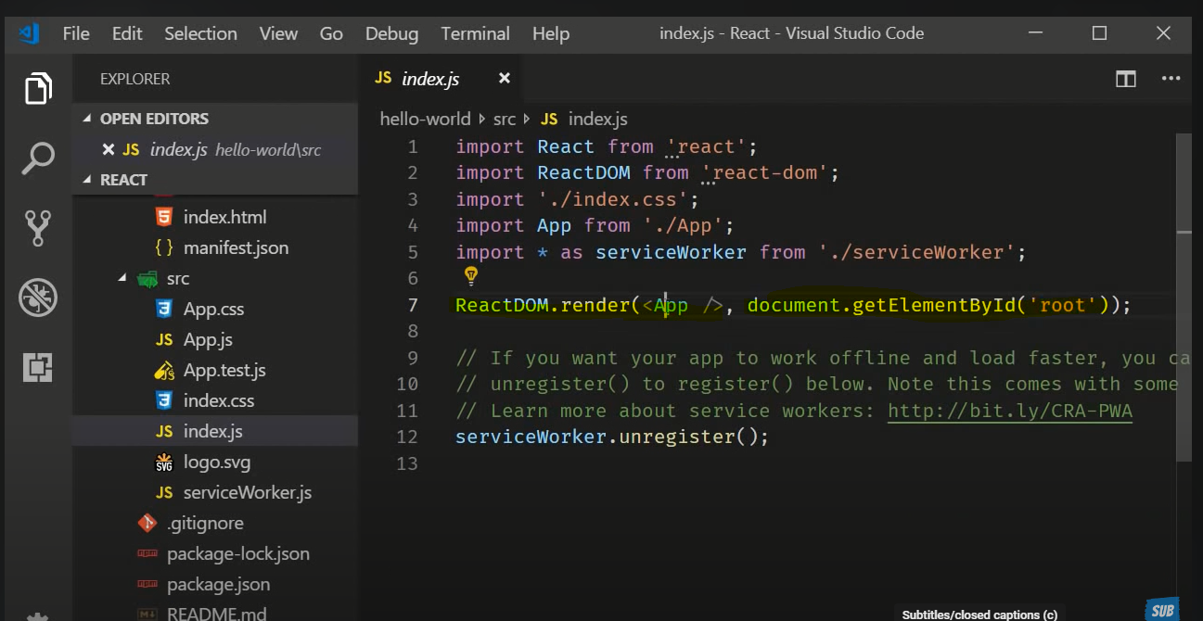

* App.js content design render on index.html and showing that html (html is responsible for showing details in the browser)

App.css : Contain css for applying that css to app component.

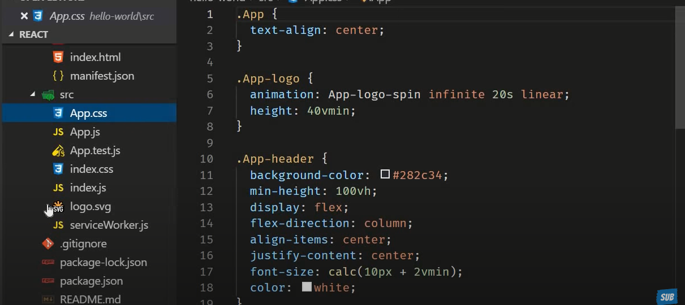

App.js :

* Html file responsible to render this design to the browser
* App component represents the view which we see in the browser.

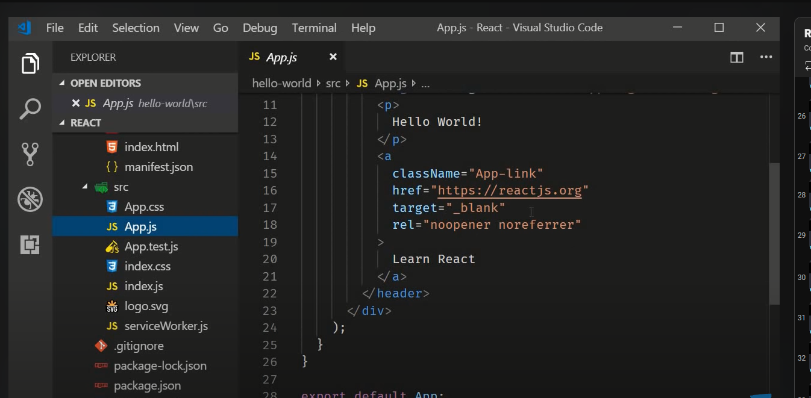

App.test.js : For unit testing

serviceWorlker.js : Concered with progressive web.